Week 2

# Section 1. Comparisons and Conditionals

## Exercise 1: Comparison Operators

### Understanding the Task:

This exercise asked us to explore and practice **comparison operators**. We were expected to check how values or variables compare using operators like **==, !=, >, <, >=,** and **<=.** The main goal was to understand how these comparisons return either True or False.

### Source Code:

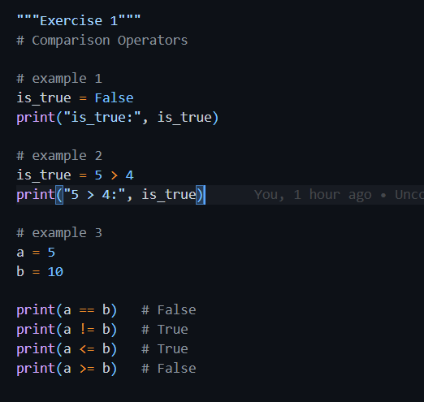

### Explanation

* In **Example 1**, I directly assigned a Boolean value ‘False’ to a variable and printed it.
* In **Example 2**, I used a comparison 5 > 4 which is True, and printed the result.
* In **Example 3**, I compared two variables a = 5 and b = 10 using all standard comparison operators to see which conditions are true.

### Time and Space Complexity

* **Time Complexity**: O(1) – All operations are constant-time comparisons.
* **Space Complexity**: O(1) – Only a few variables are stored in memory.

### Output

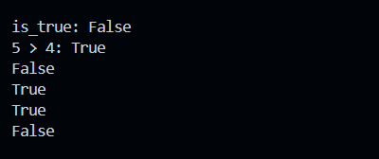

## Exercise 2: Logical Operators

### Understanding the Task

In this exercise, I was supposed to work with **logical operators**. These include **and**, **or**, and **not**. I needed to check how they behave when used with different conditions and see what kind of Boolean result they give, either True or False. The goal was to understand how we can combine multiple conditions using logic.

### Source Code

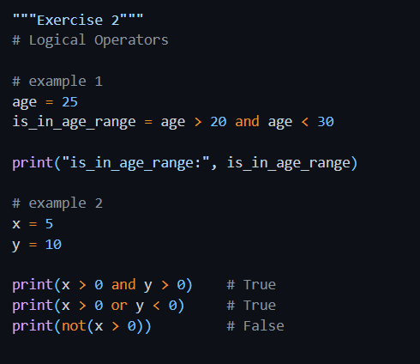

### Explanation

* In the first example, I checked if the age falls between 20 and 30. Since 25 is in that range, it returns True.
* In the second part, I used two variables x and y and tested them using different logical operators:
  + x > 0 and y > 0 checks if both values are positive — which they are.
  + x > 0 or y < 0 checks if **at least one** condition is true — which is also true.
  + not (x > 0) flips the result of x > 0. Since x is greater than 0, the original condition is True and not makes it False.

### Output

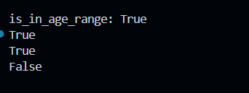

## Exercise 3: if – Conditionals

### Understanding the Task

In this task, I explored the basic use of **if statements** in Python. I had to check if a certain condition is true and then update a variable or display a message accordingly. The main idea was to learn how decisions are made in a program based on conditions.

### Source Code

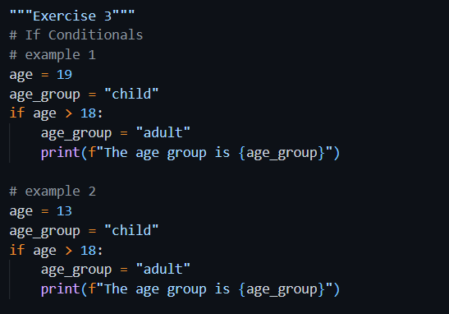

### Explanation

* In the first example, the age was 19, which is greater than 18, so it updated age group from "child" to "adult" and printed it.
* In the second example, the age was 13, so the condition age > 18 was false and nothing was printed — the program skipped the if block.

### Time Complexity and Space Complexity

* **Time Complexity**: O(1) – A single condition is checked.
* **Space Complexity**: O(1) – Only a few variables are used.

### Output



## Exercise 4: if – else Conditionals

### Understanding the Task

This task was about using the **if-else** structure. I had to write code where the program chooses between two possible actions, one if a condition is true, and another if it's false.

### Source Code

### Explanation

* In the first example, wind_speed was 30, which is not less than 10, so it printed "It is a windy day".
* In the second example, windspeed was 5, which is less than 10, so it printed "It is a calm day".

### Time Complexity and Space Complexity

* **Time Complexity**: O(1) – It just checks one condition.
* **Space Complexity**: O(1) – Minimum memory usage.

### Output

## Exercise 5: if – elif - else Conditionals

### Understanding the Task

In this exercise, I practiced using **if-Elif-else** blocks to handle multiple conditions in a clean way. This helped in writing better decision-based logic where the program chooses the right option from several possibilities.

### Source Code

### Explanation

* Four different grades were tested.
* The code checked each grade and printed a message:
  + Below 50 → “You failed”
  + Between 50–59 → “You passed”
  + Between 60–69 → “You got a good pass”
  + 70 and above → “You got an excellent pass”
* Each elif allows checking in sequence, and only one block runs depending on the value.

### Time Complexity and Space Complexity

* **Time Complexity**: O(1) – Constant time, since only a few checks are made.
* **Space Complexity**: O(1) – Few variables used.

### Output

## Exercise 6: Compare Temperatures

### Understanding the Task

This task was about comparing two temperature values. I had to check if they were equal or different and show the appropriate message using an if-else structure.

### Source Code

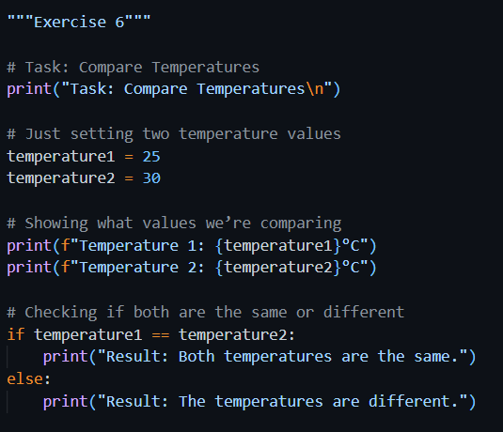

### Explanation

* The two temperatures were set to 25 and 30.
* The program displayed both values.
* Then it compared them: since 25 ≠ 30, it printed “The temperatures are different”.

### Time Complexity and Space Complexity

* **Time Complexity**: O(1) – One comparison is made.
* **Space Complexity**: O(1) – Two variables only.

### Output

Øther tasks are remaining

Week 3

# Section 1. Functions and Scope

## Exercise 1: Functions in Python

### Understanding the Task

In this task, I learned how functions work in Python and how they help make code more reusable and organized. I explored different aspects like how to define a basic function, pass parameters to it, and use keyword arguments. I also practiced using default parameter values and learned how to return results from a function. Each small sub-topic helped me understand how functions behave in different scenarios and how we can control the inputs and outputs more efficiently. This exercise gave me a solid understanding of writing clean, functional code.

#### Creating Functions

##### Source Code

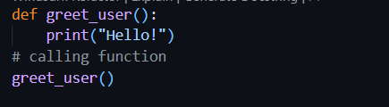

##### Explanation

Here, I created a simple function called greet_user() that prints a greeting. I called the function after defining it to run the print statement. This shows how basic functions are defined and called in Python.

##### Output



#### Function Parameters

##### Source Code 1

##### Output 1



##### Source Code 2

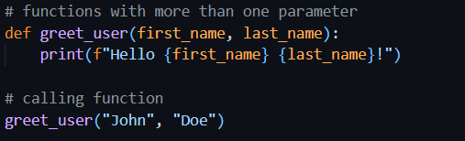

##### Output 2

##### Explanation

This version of the function takes a parameter called name. When I call greet_user("John"), it prints "Hello John!". This shows how to pass input (variables) into a function and use it inside.

#### Keyword Arguments

##### Source Code

##### Explanation

In this example, I called the same function using keyword arguments. I passed values by naming the parameters directly. This allows the arguments to be passed on in any order, which makes the code more readable.

##### Output

#### Default Values

##### Source Code

##### Explanation

This function has a default value for the university parameter. If I don’t pass the value for it, it uses "UWS" by default. But I can also override it by giving a custom value like "UWS London". This is useful when some arguments usually have a common value.

##### Output



#### Return

##### Source Code

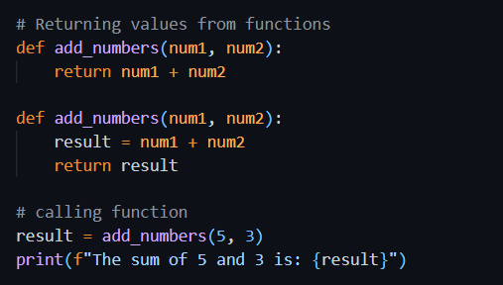

##### Output

##### Source Code

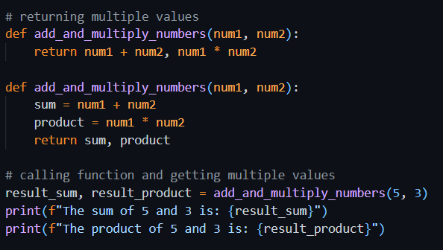

##### Output

##### Explanation

In this part, I created a function called add_numbers() that takes two numbers and returns their sum. Instead of printing the result inside the function, it sends the result back using the return keyword. I stored that value in a variable called result and printed it. This makes the function more flexible since I can use the result anywhere else in the program too.

## Task: Greet each friend in the list

### Understanding the Task

In this task, I had to create a function that takes a list of friends' names and greets each one by printing a message. The main goal was to use a for loop to go through a list and apply the same action (printing a greeting) to every item.

### Source Code

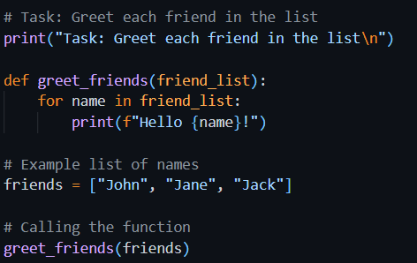

### Explanation

I defined a function greet_friends() that accepts one argument, a list of names. Inside the function, I used a for loop to iterate through the list and print "Hello" followed by each friend's name. When I called the function with a sample list like ["John", "Jane", "Jack"], it printed a greeting for each one. This is a good example of using functions and loops together.

### Time Complexity and Space Complexity

* **Time Complexity**: O(n) – because the loop runs once for each name in the list.
* **Space Complexity**: O(1) – no extra space is used other than a few variables.

### Output

## Task: Calculate Tax Based on Income and Tax Rate

### Understanding the Task

In this task, I had to write a program that calculates tax based on a given income and tax rate. It starts by testing the function with fixed values, and then allows the user to enter their own income and tax rate multiple times. The goal was to use functions, input/output, loops, and basic arithmetic.

### Source Code

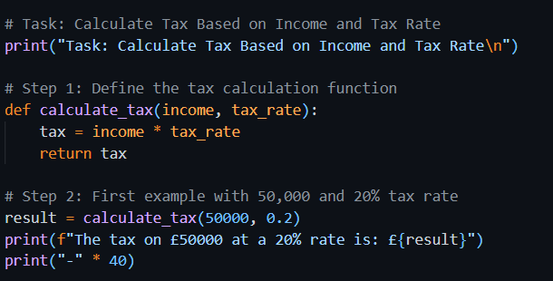

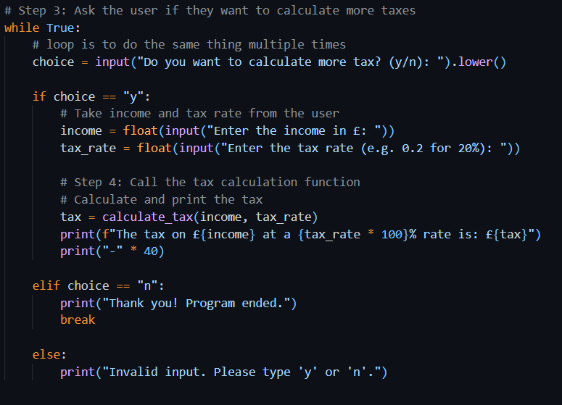

### Explanation

* First, I created a function called calculate_tax that multiplies income by tax rate and returns the result.
* I tested the function with £50,000 income and a 20% tax rate, and it correctly returned the tax.
* Then I used a while loop to allow the user to calculate tax as many times as they want.
* If the user enters 'y', it asks for income and tax rate, then prints the calculated tax using the same function.
* If the user types 'n', the program ends with a thank-you message.
* It also handles invalid inputs like any character other than 'y' or 'n'.

### Time Complexity and Space Complexity

* **Time Complexity**:
  + O(1) for each individual tax calculation
  + O(n) overall, where n is the number of times the user wants to calculate tax
* **Space Complexity**: O(1) – the program only uses a few variables regardless of input size

### Output

## Task: Compound Interest Calculator Function

### Understanding the Task

This task was about writing a function that calculates compound interest over a number of years. The function needed to handle invalid inputs and print how the investment grows year by year. In the end, it returns the final value of the investment.

### Source Code

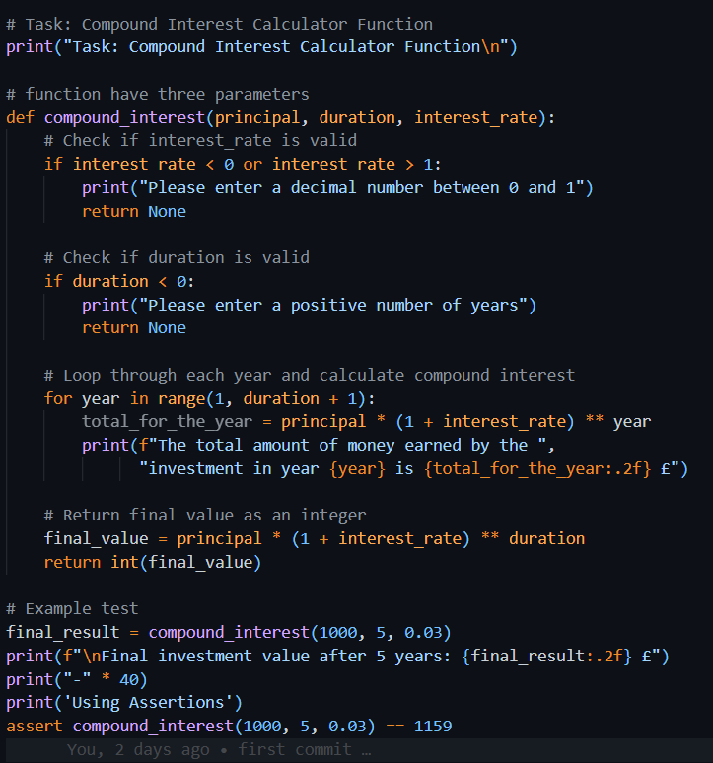

### Explanation

* The function compound_interest takes three parameters: principal, duration, and interest_rate.
* It first checks if the interest rate is between 0 and 1 and if the duration is positive. If not, it shows an error and exits early.
* Then, it uses a for loop to calculate and print the total amount at the end of each year using the compound interest formula:  
  (principal×(1+rate)year)(principal × (1 + rate) ^ year)(principal×(1+rate)year)
* Finally, it returns the total value at the end of the given duration, rounded to an integer.
* I tested the function with a £1000 investment for 5 years at 3% interest, and it correctly printed the values for each year and returned the final result.

### Time Complexity and Space Complexity

* **Time Complexity**: O(n) – The function loops once for each year (n = duration)
* **Space Complexity**: O(1) – It uses a fixed amount of memory regardless of the duration

### Output

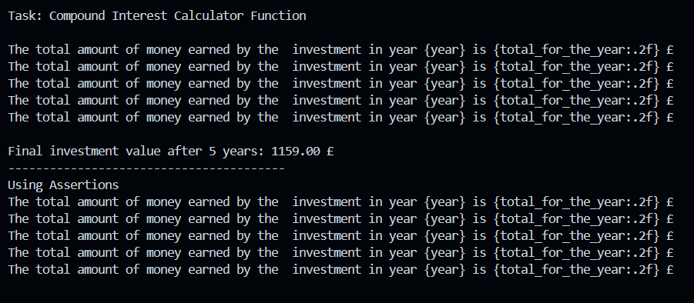

## Exercise 2: Variable Scope

### Understanding the Task

This task helped me understand how **variable scope** works in Python, especially in relation to functions. It showed the difference between variables defined inside a function (local scope) and those outside it (global scope).

### Source Code

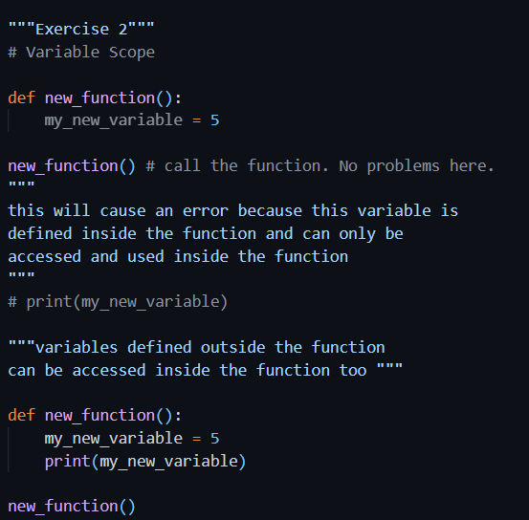

### Explanation

* In the first part, I defined a variable called my_new_variable **inside** a function and then tried to access it **outside** the function. This causes an error because the variable only exists within the function’s local scope.
* In the second part, I added a print() statement **inside** the function to access the same variable, and it worked perfectly. This proves that local variables can only be used within the function they’re defined in.
* The code also notes that **global variables** (defined outside the function) can still be accessed inside it — though this specific example doesn’t show that part in action.

### Time Complexity and Space Complexity

* **Time Complexity**: O(1) – The function runs once and does a simple assignment and print.
* **Space Complexity**: O(1) – Only one variable is stored.

### Output

#### Error

#### Corrected Code Output



# Section 2: Assertions and Errors

## Exercise 6: Assertions

### Understanding the Task

This task was about using assert statements in Python to automatically check if a function gives the expected result. Assertions are used mainly for testing.

### Source Code

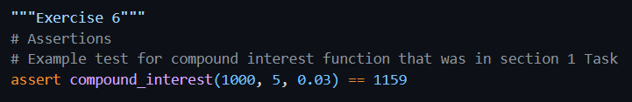

### Explanation

I used the assert keyword to test the output of the compound_interest function. If the result is not exactly 1159, the program will raise an error. Since the actual return value matches, the code runs without any issues.

### Time Complexity and Space Complexity

* **Time Complexity**: O(n) – depends on the compound interest function’s loop
* **Space Complexity**: O(1) – no extra space used

### Output

## Exercise 7: Identifying and Fixing Common Errors

### Understanding the Task

#### Syntax Error

Occurs when Python code is written incorrectly and doesn't follow the proper rules — e.g., a typo like pritn() instead of print().

##### Source Code 1 – Has Error

##### Output 1

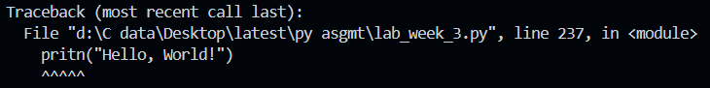

##### Source Code – Corrected

##### Output 2

##### Explanation

The original line used pritn() which is incorrect. I fixed it by writing print("Hello, World!") correctly.

#### Name Error

Happens when you try to use a variable or function name that hasn’t been defined yet.

##### Source Code 1 - Has Error

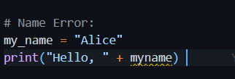

##### Output 1

##### 

##### Source Code 2 – Corrected Code

##### Output 2

##### Explanation

Originally, myname was used without being defined. I fixed it by using a properly declared variable favorite_color and printed it correctly.

#### Value Error

Occurs when a function gets the right type of data but the value is not acceptable — like converting "abc" to an integer.

##### Source Code 1 – Has Error

##### Output 1

##### Source Code 2 – Corrected Code

##### Output 2



##### Explanation

Python can’t add a string and an integer directly. I fixed it by converting "5" to int using int("5") before adding.

#### Index Error

Happens when you try to access an index in a list that doesn’t exist — like accessing index 3 in a 3-item list.

##### Source Code 1 – Has Error

##### Output 1

##### Source Code 2 – Corrected Code

##### Output 2



##### Explanation

The list only had 3 elements (index 0 to 2), but index 3 was used. I corrected it by accessing index 2, which is valid.

##### Output

#### Indentation Error

Occurs when the code isn't properly spaced. Python uses indentation to know what code belongs in loops, functions, etc.

##### Source Code 1 – Has Error

##### Output 1

##### Source Code 2 – Corrected Code

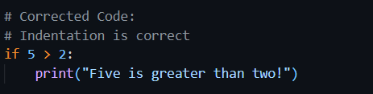

##### Output 2

##### Explanation

Python expects code blocks to be indented. The original code wasn’t indented under if. I fixed it by indenting the print() line properly.

# Section 3. Larger scale python program

## Task: To-Do list manager:

### Understanding the Task

The purpose of this task was to create a simple **To-Do List application** using basic Python features like lists, functions, conditionals, and loops. The program should allow the user to manage their daily tasks by adding them, viewing the current list, removing any task, and exiting the program using a menu system.

The focus was on writing clean, functional code and understanding how to work with user input and list operations in Python.

### Source Code

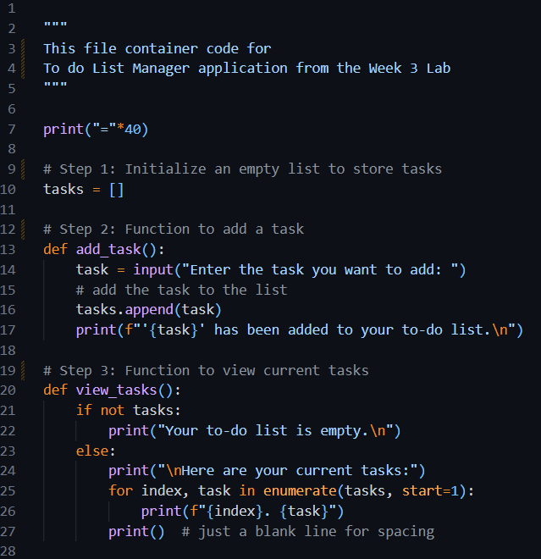

### Explanation

The program runs in a loop and offers four main options to the user:

#### 1. Initialize the Task List

At the top of the program, an empty list called tasks is created. This is where all the tasks entered by the user are stored.

#### 2. Adding a Task

The add_task() function asks the user to type in a task. Once entered, the task is added to the list, and a confirmation message is displayed.

#### 3. Viewing All Tasks

The view_tasks() function checks if the list is empty. If not, it shows all current tasks with numbers beside them for easy reference. This helps the user see what tasks they’ve added so far.

#### 4. Removing a Task

The remove_task() function lets the user delete a task by entering its number. The task list is displayed first so the user knows the correct number. The function also handles invalid input or if the list is empty.

#### 5. Menu and Loop

The program uses a while loop to repeatedly show the menu:

* 1 to Add a task
* 2 to View tasks
* 3 to Remove a task
* 4 to Quit

The user can perform any action, and the loop keeps running until the user selects the quit option.

### Time and Space Complexity

* **Time Complexity**:
  + Add Task: O(1)
  + View Tasks: O(n)
  + Remove Task: O(n) — because removing an item shifts the rest of the list
* **Space Complexity**:
  + O(n), where n is the number of tasks added by the user

### Output

###### Choice 1

Choosing 1 to add a task (one by one)

###### Choice 2

Choosing 2 to view tasks.

###### Choice 3

Choosing 3 to delete a task.

###### Choice 4

Quitting the program

Week 4

# Section 1. Python Classes

## Exercise 1: Creating Classes and Initializing Objects

### Understanding the Task

In this exercise, I was asked to create Task class which will have task details. I was also asked to define a class called TaskList that holds a list of tasks which are the objects of Tasks from the Task class and stores the owner’s name. I learned how to use the __init__ method to initialize class attributes.

### Source Code

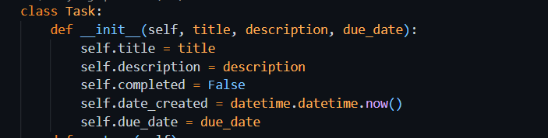

### Explanation

This class is used to represent a single task in a to-do list. When a new Task object is created, it automatically stores:

* **title**: The name or heading of the task
* **description**: A short explanation about what the task is
* **completed**: A boolean value that shows whether the task is done (initially set to False)
* **date_created**: The current date and time when the task is created
* **due_date**: The deadline for the task

This helps organize all the important details of one task inside a single object.

### Source Code

### Explanation

This class is used to manage a list of tasks for one user.

* **owner**: Stores the name of the person who owns the task list
* **tasks**: An empty list that will hold multiple Task objects

This class acts as a container for managing multiple tasks under one user.

#### Object Creation

For Task Class:



And for Task List class:

## Exercise 2: Adding Methods

### Understanding the Task

In this task, I was asked to expand the Task class by adding useful methods that allow interacting with task data. The goal was to practice writing instance methods for updating task attributes, such as marking it as complete, changing the title, or changing the due date. This helped me understand how to define custom behaviors inside a class.

### Source Code

### Explanation

#### mark_completed() Method

* This method is intended to mark the task as completed.
* Currently, it just prints a message, but in a full version, it would update the completed status to True.

#### change_title(new_title) Method

* This method is designed to change the title of the task.
* It prints a message as a placeholder, but normally it would update the self.title.

#### change_due_date(new_date) Method

* This is meant to update the due date of the task.
* Right now, it prints a confirmation message, but ideally it would modify self.due_date.

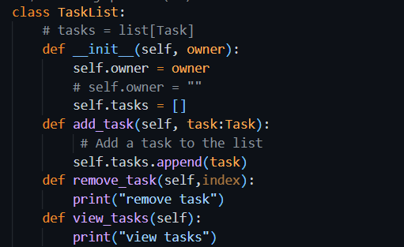

#### add_task(self, task: Task):

Adds a new Task object to the tasks list using the .append() method.

*remove_task(self, index):*

This function is meant to remove a task using a user-provided index. However, the actual deletion line (del self.tasks[index - 1]) is commented out. Instead, it only prints debug information like the task's position and name. This shows that the logic was still under development or being tested.

*view_tasks(self):*

Displays all tasks in the list. If the list is empty, it shows a message saying there are no tasks. Otherwise, it loops through the list and prints each task with a number.

This structure shows how methods can be added to a class to make it more dynamic and interactive.

## Task: Add logic to methods defined

In Task Class, I have implemented logic of functions e.g. mark_completed(), change_title(), change_due_date(). When any of these details will be required to be changed of specific task, these methods will be called respectively

In TaskList Class, I have implemented logic of methods e.g. add_task(), view_tasks(), remove_task(). These methods will modify the tasks_list accordingly.

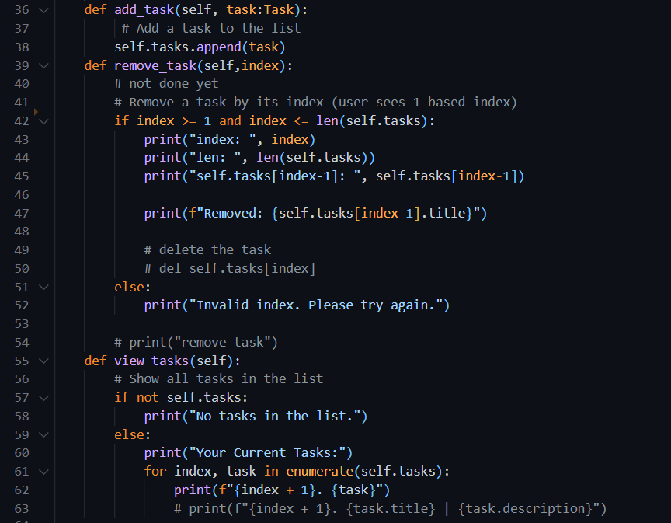

List_options() method will be calling for showing menu to the user and then calling the respective methods according to the choice.

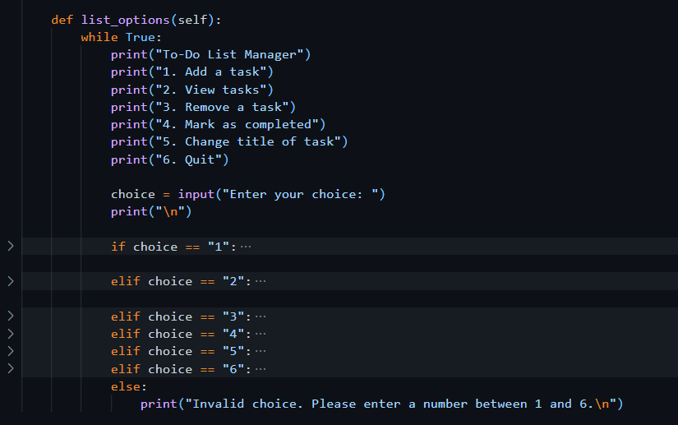

## Exercise 3: Testing the Functionality

Testing is done to check whether the code is working correctly or not.

### 

### Output

### Code

Choosing one option lets us add one new task to the list at a time. Its working correctly

### Output

### Code

Choosing option 2 to view all the tasks. Its working correctly

### Output

### Code

Choosing option 3 to delete the task

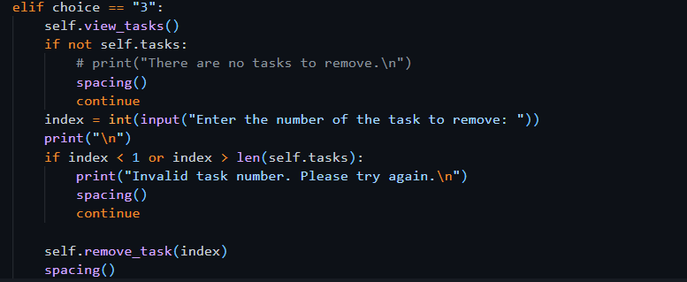

### Output

## Exercise 4: Composition

**Composition** is an object-oriented programming concept where one class is made up of or contains objects of another class.

### Source Code

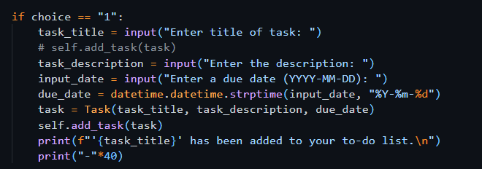

### Explanation

This code is taking title, desc and due date of a task as input from user. It then saves information using object of Task Class. It then adds that object to the Task List class using add_task() method. In this way TaskList can have many Tasks

## _str_ method

If we simply print the Task object , it will show something like



But we want to see the details of Task e.g. title, description, etc. For this purpose, we use _str_ method, which will convert the object into string and then will show it to user in readable format.



## Task: Change code in the Task Class

### Understanding the Task

‘**completed’** attribute is to be added to the class to mark the status of the task. First, it should be false to show that the task is not completed yet. There should be a function **mark_completed()** to update the status of the task. **change_title()** method will change the title of the respective task. All these details will be shown to the user by **_str_** method.

### Source Code

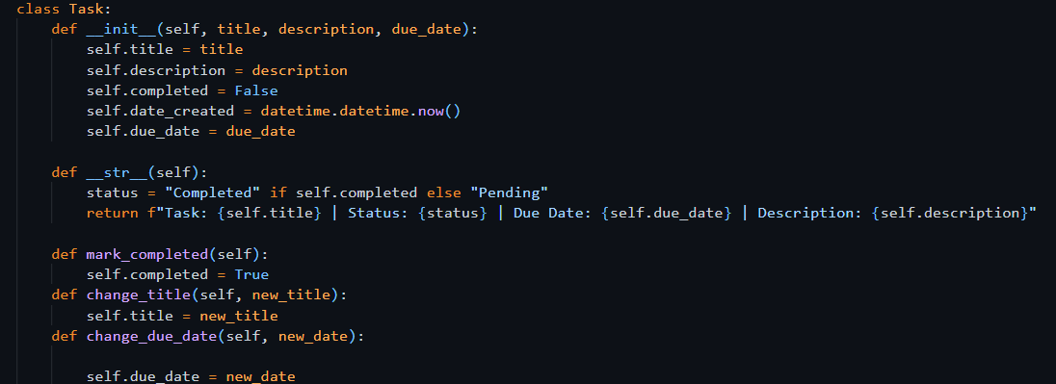

## Task: Update list_options() method

The options mark_completed(), change_title(), change_due_date() should be added to the menu items to show to the user to operate.

If Elif statements

# Section 2. Python Libraries

Libraries are collections of functions and methods that allow you to perform actions, without having written the code yourself.

## Exercise 1: Adding Dates

### Understanding the Task

It is important for each task to have both the date it was created and the due date. To handle this, I used Python’s built-in **datetime** library. A method called **change_due_date** was also added so that the due date can be updated later if needed.

### Source Code

It is required to import the library, mostly at the top of the file.

**datetime** is the python library which is used to work with the dates and time. It lets us to :

* Get the current date and time
* Format dates in different ways
* Compare dates
* Add or subtract days, months, etc.
* Convert strings into date objects

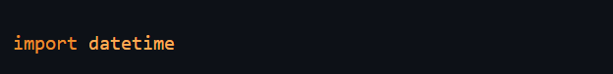

In this program, it is required to convert the string date (input from user) into datetime object and then save it to the Task. **strptime** also known as ‘String Parse Time’ is used to **convert a date string into a proper datetime object**, using a specific format. It takes 2 arguments, one is string and other is format, in which the string has to be converted.

Or getting the present date and time



## Task: Add the due_date functionality

For changing due date of the task, I have created ‘change_due_date()’



Modification of If-else statements in list_options() method for changing due date

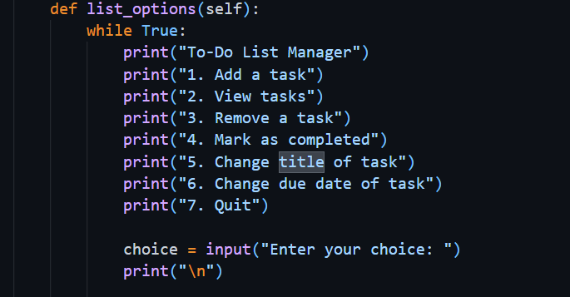

### Output

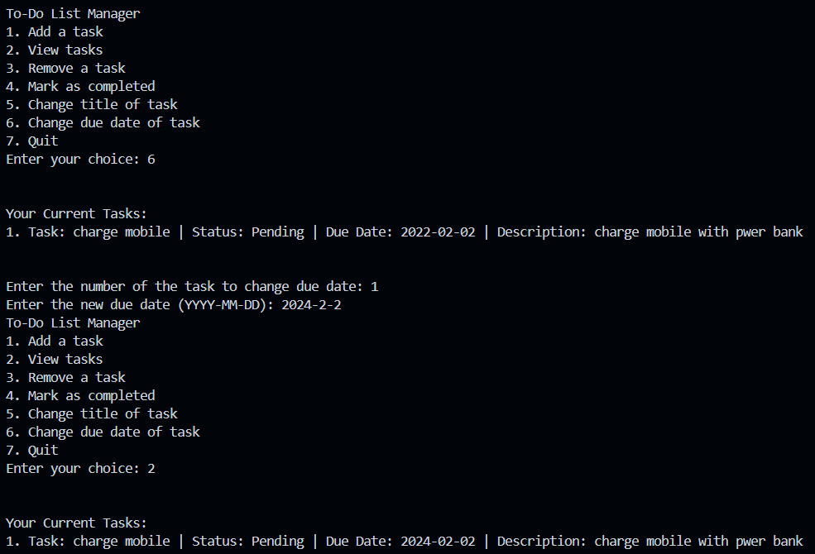

# Section 3. Modularizing the code

## Exercise 1: Restructuring

### Understanding the Task

In this task, I learned the importance of organizing code by splitting it into multiple files, which is called **modularization**. Instead of writing everything in one large script, I had to separate my code into different modules, each handling a specific part of the program.

I was asked to create a new folder called ToDoApp, then inside it:

* Create a main.py file to act as the **main.py entry point** of the application.
* Move the **Task** class into a new file called **task.py**.
* Move the **TaskList** class into another file called **task_list.py**.

This structure helps keep the code cleaner, easier to understand, and more manageable, especially as the program grows. I also had to handle importing properly.

### Explanation

To make the code more organized, I divided it into three separate Python files:

#### main.py

This file acts as the **entry point** of the program. It contains the user interface (menu), takes input from the user, and calls functions from other files. This is the file I run to start the application.

#### task.py

This module contains the **Task class**, which holds all the properties of a task, like title, description, due date, date created, and whether the task is completed. It also includes useful methods like:

* mark_completed()
* change_title()
* change_description()
* change_due_date()

#### task_list.py

This file contains the **TaskList class**, which manages a list of Task objects. It allows adding, removing, viewing, and checking overdue tasks.

### Output

* The program runs smoothly by calling everything from main.py, while the logic stays separated in task.py and task_list.py.
* The output remains the same as before — the user can add, view, update, or remove tasks using the menu.
* Code is now cleaner, easier to debug, and simpler to extend in the future.
* If I ever want to reuse the Task or TaskList classes in another project, I can do so without rewriting them.
* It follows a good programming habit of separating logic into modules, which is useful for teamwork and larger projects.

#### Import statement

When one file contents are being used in another file, it must be imported into the second file at the top, otherwise it will give error.

### Code

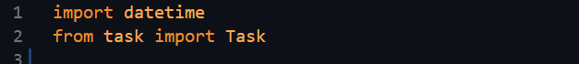

The second import statement says that I have imported Task class from task file. ‘task’ file is basically task.py file.

## Exercise 2: Main()

### Understanding the Task

In this task, I had to properly define a **main() function** that serves as the starting point of the program. The purpose was to cleanly separate the program's setup logic and make the code more structured.

Instead of writing everything directly at the bottom of the file, I placed the core startup code inside main() and then called it safely using:

### Source Code

### Explanation

* Inside the main() function, I created an instance of TaskList, passing a name (e.g., "Ahmed").
* Then I called task_list.list_options() — this method displays the menu and lets the user interact with the to-do list.
* The condition if __name__ == "__main__" makes sure the app runs only when executed directly, not when imported.

This structure is helpful for testing, modularity, and professional coding practices.

## Task: Move Menu Logic to main() in main.py

### Understanding the Task

In this task, I was required to remove the list_options() method from the TaskList class and move its code into the main() function inside main.py. The purpose of this change is to make the code more modular and better structured.

Since the menu and user interaction part is not the responsibility of the TaskList class (which should only manage tasks), it makes more sense to place that logic in main.py, where the user runs the program.

### Explanation

Previously, the TaskList class included a method called list_options() that handled everything — from displaying the menu to taking user input and performing actions like adding or removing tasks. But that mixed two responsibilities into one class:

* Task management
* User interaction

To follow proper object-oriented design, I:

* Opened task_list.py and **copied the entire list_options() method’s content**
* Pasted the code inside the main() function in main.py
* Removed the list_options() method from TaskList class
* Deleted the line task_list.list_options() and replaced it with the actual menu logic now inside main()

Now, main.py handles the user interaction, and TaskList only manages the task-related functions. This separation improves the design and makes future updates (like replacing the menu with a GUI) much easier.

## Task: Using task_list object instead of self

### Understanding the Task

When I moved the menu logic from the TaskList class into the main() function in main.py, I had to replace all instances of self with task_list. This was necessary because I was no longer inside a class method. I was now working in a regular function (main()), where self is not available. The task_list object was already created earlier in main() to represent the user's task manager, so I used it to access tasklist class methods.

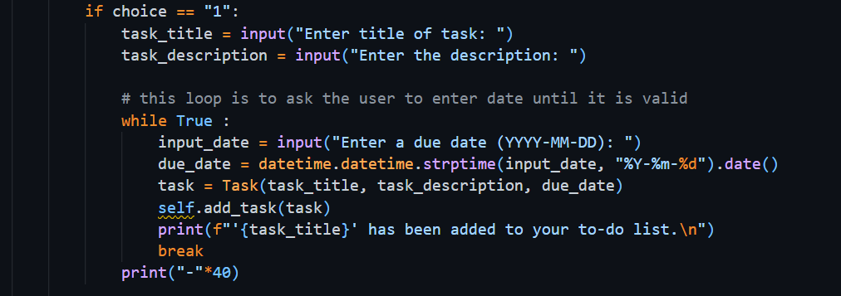

### Explanation

In the original list_options() method inside the TaskList class, all method calls used self, like this:

But after moving this logic to main.py, we’re no longer inside the TaskList class. So, we need to use the actual object created in main(), which is:



Now, to call methods on this object, I changed self to task_list, like:



## Task: Add Helper function for test tasks

### Understanding the Task

In this task, I was asked to add a helper function named propagate_task_list() that would automatically fill the task list with some sample tasks when the program starts. The main reason for this was to make testing easier, so I wouldn’t have to manually add tasks every time I run the program.

The function takes a TaskList object and adds several tasks to it, with different due dates (some in the past, some in the future). Then it returns the updated task list back to the main program.

### Source Code

#### Definition

#### Usage

### Explanation

To complete this task, I followed these steps:

#### Defined the Function:

I copied the propagate_task_list() function into the top section of my main.py file, right above the main() function. Inside this function, I added six sample tasks with various due dates.

#### Called It in main():

Inside my main() function, after creating the task list object.

This made sure that every time I run the program, the task list already includes some tasks.

#### Testing Becomes Easier:

Now when I run the app, I can immediately test features like viewing tasks, marking them as completed, removing them, or checking overdue tasks, without entering tasks manually each time.

This step didn’t change how the app behaves for the user, but it made my development and testing process a lot faster and smoother.

### Output

# Section 4. Type Checking and Documenting your Code

## Exercise 1: Type Checking

### Understanding the Task

In this exercise, I learned how to use **type hints** in Python to make my code cleaner, safer, and easier to understand. Although Python doesn't force you to declare variable types (like Java or C++), it's considered good practice to include them using the syntax variable_name: type.

Type hints help:

* Prevent bugs by catching type-related mistakes early.
* Improve code readability.
* Allow editors like VS Code to show helpful suggestions or warnings.

#### Type Hints for Method Parameters

This part showed me how to define what type of input (parameter) a method or function expects. For example:



This means title should be a str and date_due should be a datetime object.  
It helps others (and me) understand what kind of values should be passed into the method.

Another example:

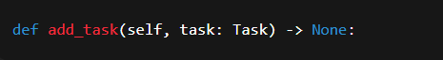

This method is expecting an object of type Task.

#### Type Hints for Return Values

“I also learned how to show what type of value a function returns by using the -> arrow

This means the __str__() method will return a string.  
It’s useful because when I call this method later, I’ll know exactly what kind of output to expect.

## Exercise 2: Docstrings and Comments

### Understanding the Task

In this task, I learned the importance of **documenting code** so that it becomes easier to understand — both for myself in the future and for others who may read it. I explored two main ways of doing this:

1. **Comments** – Used to explain parts of the code in plain language.
2. **Docstrings** – Used to describe what a class, method, or function does. These are written inside triple quotes right after the function or class definition.

The goal was to practice writing both, so the code becomes more readable and professional.

### Explanation

#### Comments:

I used # to add short notes inside my code to explain what each line or block is doing. For example:



#### Docstrings:

These are placed inside triple quotes """ """ and written right below the function or class header. They explain what the method/class is for, what arguments it takes, and what it returns (if anything). For example:

By adding docstrings and comments, my code became easier to read and work with. It also helped me stay organized and made it easier to review or debug things later.

## Portfolio Exercise 1: Adding Description Attribute to Task

### Understanding the Task

In this task, I was asked to improve the Task class by adding an optional **description** feature. This allows each task to have some extra details written about it, but it's not required.

I had to:

* Update the __init__ method so that the description can be passed when creating a task.
* Add a change_description() method to update the description later.
* Modify the __str__() method so that the description is included when printing the task.
* Lastly, I needed to update the main() function so that the user can change the task description through the menu (in the option where title and due date are already being updated).

### Explanation

* I started by updating the constructor like this:

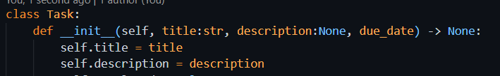

This made the description optional by setting its default value to None.

* Then I added a method:

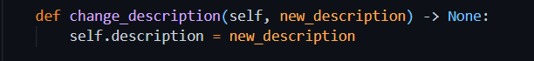

This allowed the user to change the description any time they want.

* In the __str__() method, I added the description to the return string so that whenever a task is displayed, its description shows up too.
* Finally, in main.py, I added an input option for the user to update the task’s description in the menu that also handles updating title and due date.

## Portfolio Exercise 2: View overdue tasks

### Understanding the Task

In this task, I had to add a feature that lets the user see all the **overdue tasks** — meaning tasks whose due date has already passed. For this, I needed to:

* Create a method called view_overdue_tasks() inside the TaskList class.
* Update the main() function and add a new menu option that calls this method.

This helps users easily track which tasks they’ve missed or need urgent attention.

### Explanation

In the TaskList class, I wrote a new method called view_overdue_tasks() which:

* Loops through all tasks.
* Checks if the due_date is **less than today’s date** using datetime.date.today().
* Prints those tasks as overdue.

Then, in main.py, I added a new choice in the menu, that calls this method when selected.

### Output

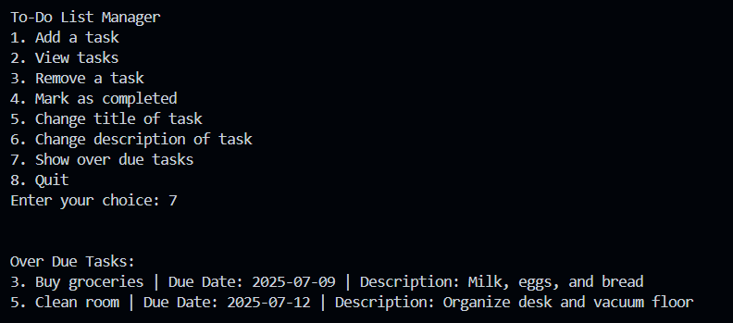

Week 5

# Section 1. Inheritance

## Exercise 1: Simple Inheritance

### Understanding the Task

In this exercise, I learned the concept of **inheritance** in object-oriented programming. The main goal was to understand how a child’s class can reuse and extend the features of a parent class. For example, since a **Car is a Vehicle**, we can create a Car class that inherits from a base Vehicle class.

The idea is to avoid repeating code. We define common features like colour, weight, and max_speed once in the parent (Vehicle) class and then let child classes like Plane or Car use those features directly. Each child can also have its own specific attributes (like wingspan for a plane).

### Explanation

* I started by creating a base class Vehicle with common properties.
* Then I made a child class (like Plane or Car) using inheritance like this:



This means Car will automatically get everything from Vehicle.

* I also practiced **method overriding**, where I redefined the move() method inside the child class to change its output. For example:

Even though the parent Vehicle class had its own move() method, this allowed me to customize it for each specific vehicle.

This exercise helped me understand how inheritance helps reduce code repetition, makes programs easier to organize, and supports flexible custom behavior in child classes.

#### Object Creation

##### Output

#### Adding more attributes to child class

Child class has all the attributes of parent class, but in some cases we need to add new attributes to child classes. For example, here in example of Car, the **form_factor** has to be added.

Creating the object with form factor:



## Exercise 2: Super () function

super() is a special function used inside a **child class** to call a method from its **parent class**.

It's mostly used in **constructors (__init__)** to make sure the parent class is properly initialized before the child class adds more functionality.

### Output

## Task: Create ElectricCar and the PetrolCar class.

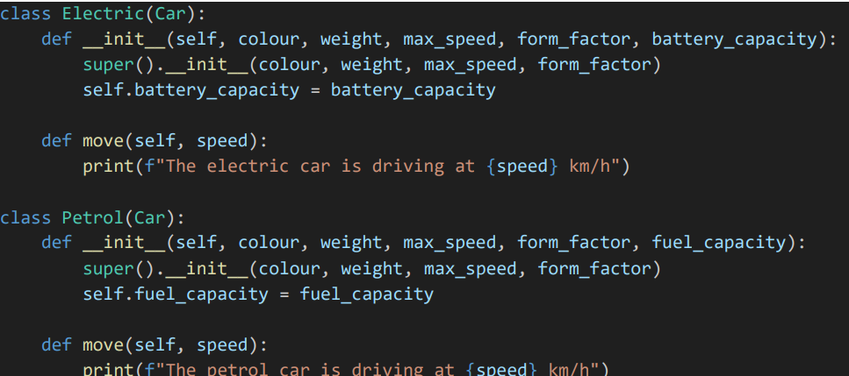

#### Test

##### Output

## Task: Adding max range parameter

Some vehicles have max range, but some do not have. That’s why max_range attribute is set to be None on default. If any vehicle has this value, it will be used.

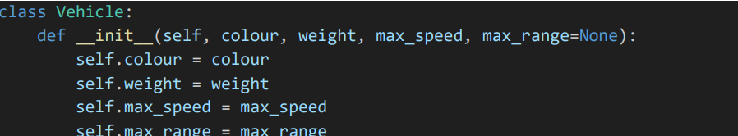

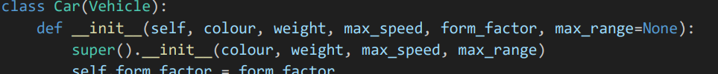

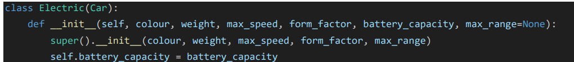

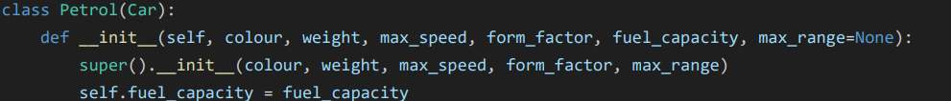

Using max range in electric car move method

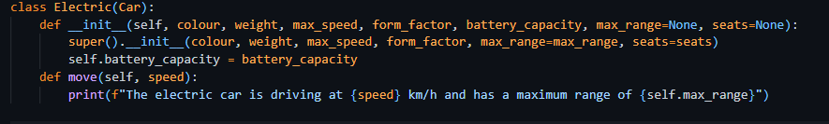

## Exercise 2: kwargs**

By using kwargs**, we can pass as many keyword arguments as possible. These are stored in dictionary data structure  
To use kwargs**, add this keyword as a parameter to any child class that is derived from Vehicle. Then pass this keyword to the parent class using super() function.

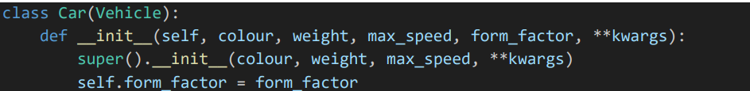

### Understanding the Task

In this task, I learned how to use **kwargs in a function or constructor.  
The purpose of **kwargs is to allow a function or method to accept **any number of keyword arguments** (like seats=4, max_range=200) even if they aren’t explicitly listed in the parameter list.

This is helpful when working with **inheritance** because sometimes a child’s class needs to pass extra arguments to the parent class without knowing exactly what those arguments are.

### Explanation

* **kwargs stands for **"keyword arguments"**
* It collects any extra named arguments as a dictionary

### Source Code

### Output

## Task: Adding seats attribute

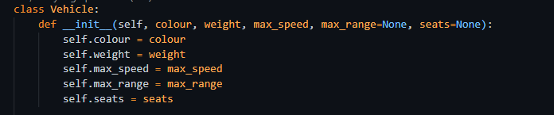

### Test

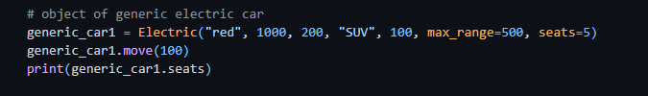

### Output



## Task: Creating Multilevel Inheritance

### Understanding the Task

In this task, I was asked to extend the Vehicle class by adding a new child class called Plane, and two more specific child classes from that, Propeller and Jet. This type of inheritance is called **multilevel inheritance.**

Each of these subclasses should:

* Inherit common vehicle features like colour, weight, and max_speed
* Add their own unique attribute:
  + Plane → wingspan
  + Propeller → propeller_diameter
  + Jet → engine_thrust

Also, each class should have its own version of the move() method, and since they are all flying machines, their output should say **"flying"** instead of "**driving**" or "**moving**".

### Explanation

* I started by creating a Plane class that **inherits from** Vehicle.
* Inside Plane, I added the extra attribute wingspan, and overrode the move() method to say respective text:

* Then, I created two more child classes:
  + Propeller(Plane) → adds propeller_diameter
  + Jet(Plane) → adds engine_thrust

* Each subclass also had its own custom move() method to match its type.
* I tested each class by creating objects and printing their attributes to make sure everything worked as expected.

# Section 3. Multiple Inheritance

### Understanding the Task

In this task, I had to create a class called FlyingCar that inherits from **both** the Car class and the Plane class. This is a good example of **multiple inheritance**, where a child’s class gets features from more than one parent’s class.

Since a flying car has the properties of both a car (like wheels and form factors) and a plane (like wingspan), it makes sense to inherit from both.

### Explanation

* I created the FlyingCar class.

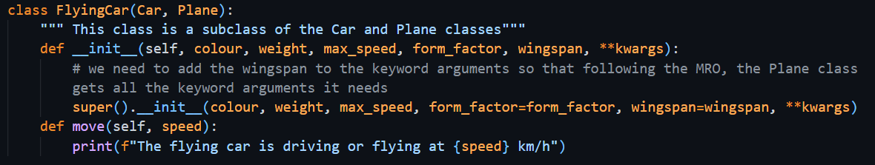

* In the constructor (__init__), I used super() to call the constructors of the parent classes and passed all necessary arguments like form_factor and wingspan.  
  Since Car and Plane both come from Vehicle, I made sure to use **kwargs to pass extra arguments smoothly.
* I also overrode the move()
* I created an object of **FlyingCar** to test whether all attributes (from both car and plane) were set correctly, like **form_factor,** wingspan and seats.

This task helped me understand how multiple inheritance works in Python, and how to combine behaviors from different classes into one.

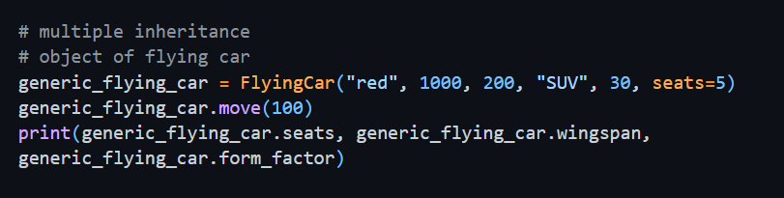

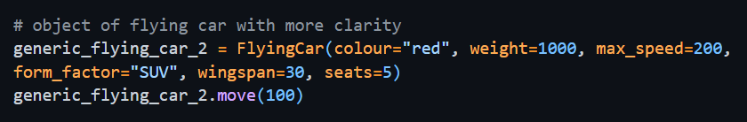

### Output

# Section 4. Polymorphism

Polymorphism allows different classes to have a **common method name** (like move()), but each class can perform **its own version** of that method.

### Understanding the Task

The idea is that we don’t need to know what kind of object we’re working with. If it has the method, we can just call it, and Python will run the correct version automatically. This is especially powerful when we’re looping over objects of different types.

### Explanation

The most common example of polymorphism is when a **parent class has a method**, and each **child class overrides** it with its own behavior. It means every child class also has the method with same name and same arguments but with different implementation

Let’s say we have:

* A Vehicle class → has a move() method
* Car, Plane, and FlyingCar subclasses → each with their own version of move()

Even though the method name move() is the same, the **output will depend on which object** is calling it. This is known as **method overriding**, and it’s a core part of polymorphism.

### Source Code

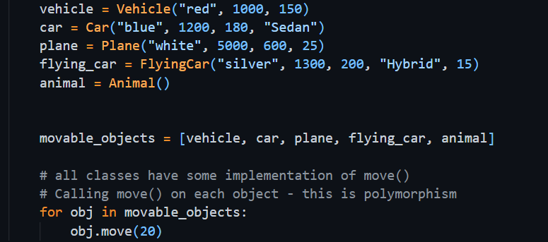

### Explanation

Creating objects of different classes with their respective arguments one by one. Saving all objects in a list and then calling move method of each object displaying the concept of polymorphism.

### Output

